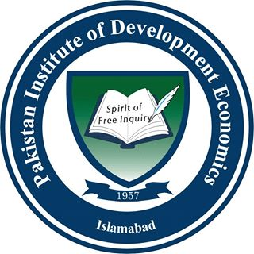 | Pakistan Institute of Development Economics, Islamabad
Faculty Course Review Report

PROFORMA – 2

(To be filled by each teacher at the time of Course Completion)

For completion by the course instructor and transmission to QEC through Head of Department together with copies of the Course outline
Department: |  |  | Faculty:
Course Code: |  | Title:
Session |  | Semester | Fall | Spring | Summer
Credit Value: |  | Level: |  | Prerequisites:
Name of Course Instructor: |  | No. of Students Contact Hours | Lectures | Other (Please State)
 |  |  | Seminars
Assessment Methods: Give details (no. & length of assignments, exams, weightage etc)

Distribution of Grade / Marks and other Outcomes: (adopt the grading system as required)
Grade / Marks
Originally
Registered
and other
% Grade
A
Outcomes:
F
Withdrawal
Total
Post Graduate | Originally  Registered | % Grade  A  A | % Grade  B  A °A Grade  B | % Grade  C  A % GCCCCCrade  C | D | E | No Grade | Withdrawal | Total
No. of Students

Overview/Evaluation (Course Instructor’s Comments)
Feedback: first summarize, then comment on feedback received from:
(These boxes will expand as you type in your answer.)
- Curriculum: Comment on the continuing appropriateness of the Course curriculum in relation to the intended learning outcomes (course objectives) | Comment Box
- Assessment: Comment on the continuing effectiveness of method(s) of assessment in relation to the intended learning outcomes (Course objectives) | Comment Box
- Enhancement: Comment on the implementation of any changes proposed earlier in Faculty Course Review Reports (if applicable) | Comment Box
- Outline any changes in the future delivery or structure of the Course that this semester/term's experience may prompt | Comment Box
- External Examiners or Moderators (if any) | Comment Box
Name:_______________________ (Course Instructor) | Date:________________
Name:_______________________  (Head of Department) | Date:________________

