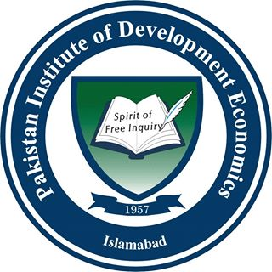 | Pakistan Institute of Development Economics, Islamabad

RESEARCH STUDENT PROGRESS REVIEW FORM
PROFORMA - 4
(To be filled out by Master/ M.Phil / Ph.D Research Students)

To be submitted by the HoD / Dept. Coordinator / Program Team to QEC

For Research Student to Complete:
- Date of admission to the department

- Date of initiation of research

- Date of completion of Course work

- Number of credit hours completed

- Date of Synopsis Defense

- Cumulative Grade Point Average (CGPA) secured

- Please outline details of progress in your research since your last review (including any research publications):

- Do you have any comments on the level of supervision received?

- What do you plan to achieve over the next 6 months?
- Do you have any comments on generic or subject-specialist training you may have received or would like to receive internally and / or externally?

- Do you have sufficient research material / commodities available?

Student: _________________________ Date: __________________________

Departmental Council/Supervisory Committee Comments:
(Please comment on and benchmark the student’s progress against your University’s internal and external HEC Quality Criteria for Master/PhD/MPhil Studies)
Comment Box

Principal Supervisor: _____________________________ Date: _______________________

Co-Supervisor: _____________________________ Date: _______________________

Co-Supervisor: _____________________________ Date: _______________________

Head of Department Comments:
Comment Box

Signature: _____________________________ Date: _______________________

